**Postman with Jenkins:**

Open Jenkins and install the plugins that required to run the collection for that install Nodejs plugin

For that got to manage Jenkins-plugins-Available plugins-search Nodejs and install ,After that we can see the plugin in installed plugins.

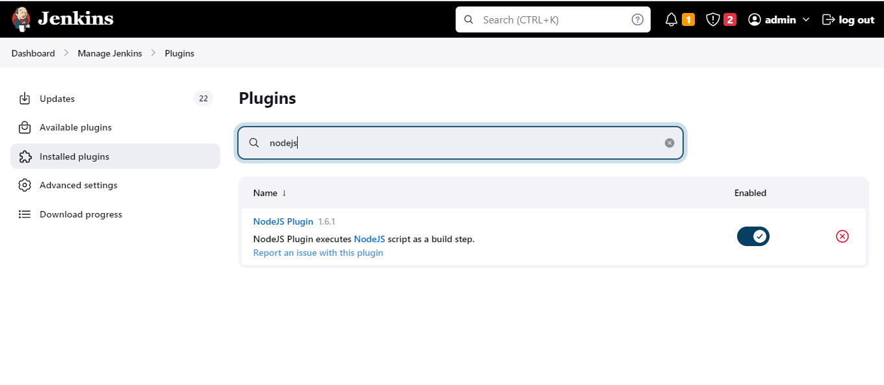

Now go to manage Jenkins-tools and add node js and add like given below and give path to node js file in local machine.

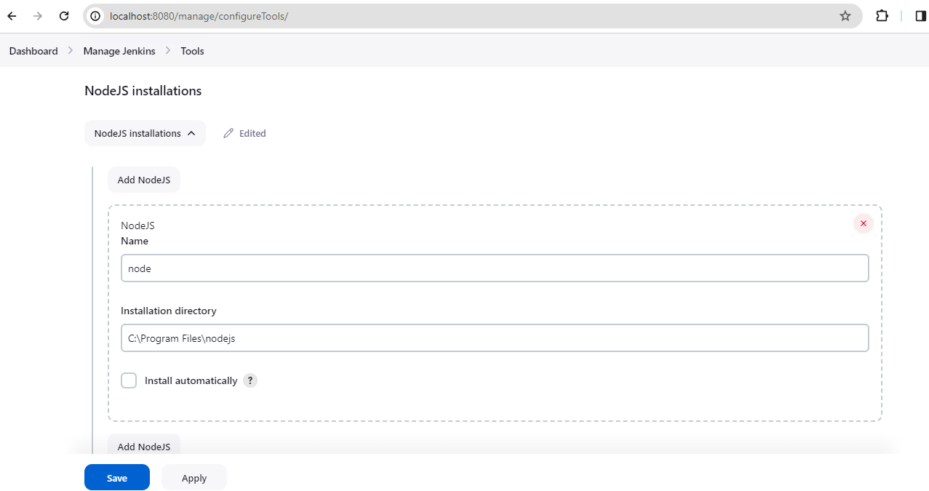

Now go to the postman and select the collection which we want to run through jenkins,and select as below.

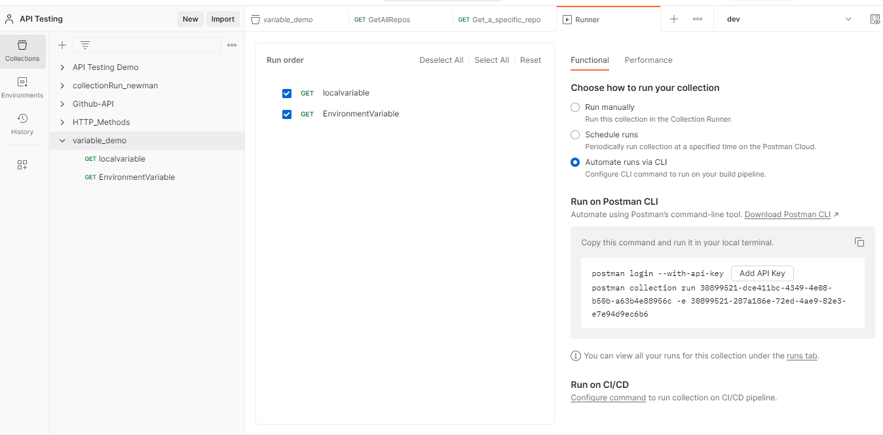

And select the configure option in bottom and script generated copy that script and open jenkins and create new job with pipeline and paste the script as given below.

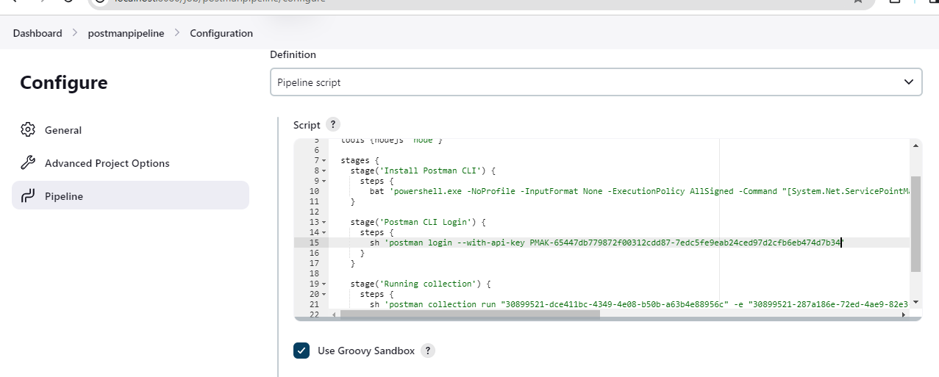

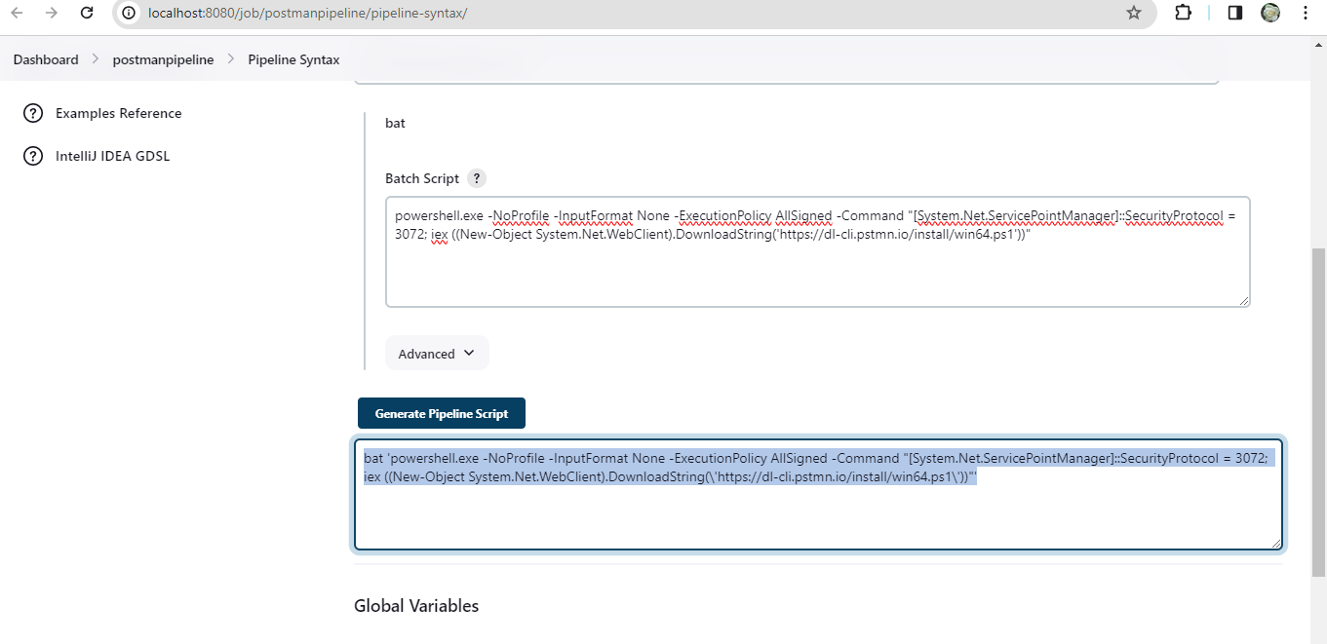

After setting everything build the config and executed as given below.

